**Week 1 Excel**

### **Microsoft Excel**

Go to the course website and download the files:

1. Week1-Excel-Instructions.pdf
2. Week1-Excel-Data.xlsx

**1.4.2 Excel: Lookup Demo**

Data: Use the Lookup worksheet for this exercise.

Objective: Search and retrieve data from a column or row.

Purpose: A lookup function scans a column of data to find a match, then returns a value from a second column. This technique is call vertical lookup (VLOOKUP), but there is also a horizontal lookup (HLOOKUP). The format is:

VLOOKUP(lookup value, table range, column index, range lookup)

Where: Lookup value in the value you search on

Table range is the group of rows and columns searched

Column index in the column number with the table range for the return value

Range lookup is a flag indicating whether non-exact matches are allowed; if FALSE, then only exact matches will return a value; if TRUE or omitted, then it assumes the data is sorted and uses the first row where the value is the table is less than or equal to the lookup value

Let’s first identify tax rates by income level. The steps are:

1. We can create a new named range called TaxTable by highlighting the data under income, US Tax, and NY Tax, then naming it TaxTable.
2. In A7, enter an income.
3. In B7, enter =vlookup(A7,TaxTable,2) to find the US Tax.
4. In C7, enter =vlookup(A7,TaxTable,3) to find the NY Tax.

Next, use VLOOKUP where the data is not sorted:

1. Create a range called ProductPrice by highlighting the data from A11 through B15
2. In A17, enter a product from the list (or not, to test the VLOOKUP)
3. In B17, enter =vlookup(A17,ProductPrice,2,FALSE)

Finally, build a VLOOKUP for sales by state.

1. In H1, type State
2. In I1, type Sales
3. In H2, type in a two-letter code for a state
4. In I2, enter =vlookup(H2,E2:F51,2)

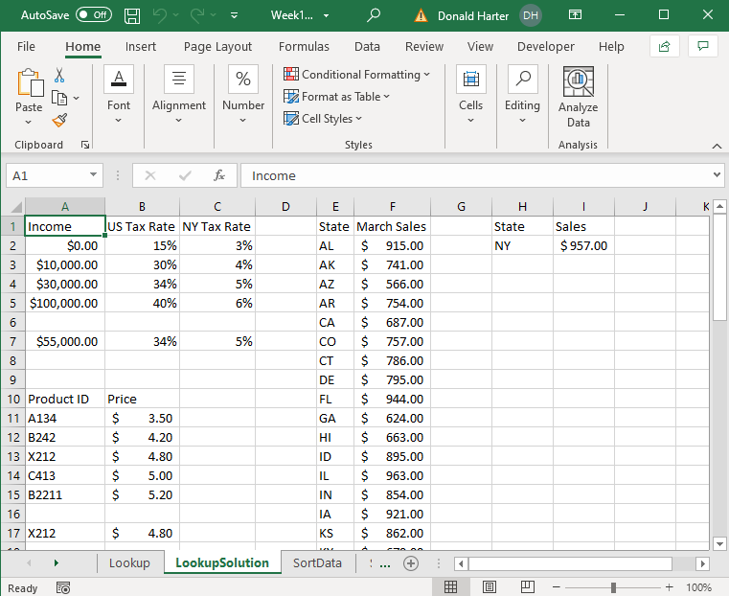

**1.4.3 Excel: Sorting and Filters Demo**

Data: Use the SortData, FilterData, and PivotData worksheets for these exercises.

Objective: Put data in order (sort), select a subset (filter), and summarize data in a table (pivot table).

**Sorting Data**

1. Use the SortData spreadsheet for this exercise.

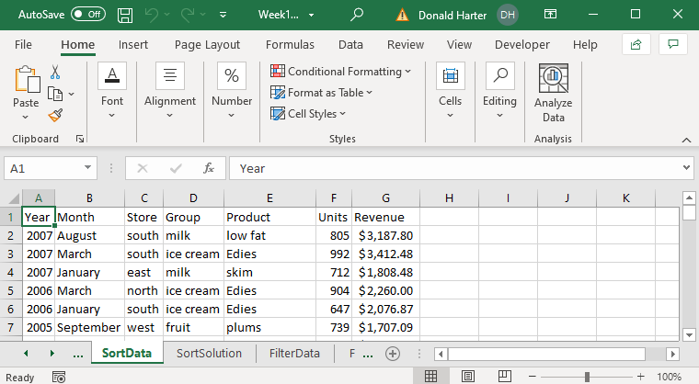

1. To sort data, highlight the top of the columns (A through G). The entire columns should be highlighted.
2. Click on the Data tab at the top of the spreadsheet.
3. Click on Sort; note that “My data has headers” is checked. Why is it checked?
4. Select the first sort criteria: Store.
5. Click on Add Level, then add the second sort criteria: Group.

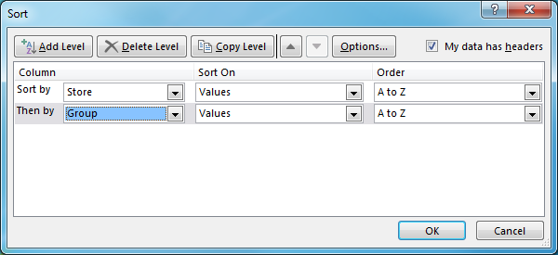

1. Click OK, and the data is sorted.
2. How would you sort from Z to A (reverse alphabetical order)? Why would you want to sort in a different order?

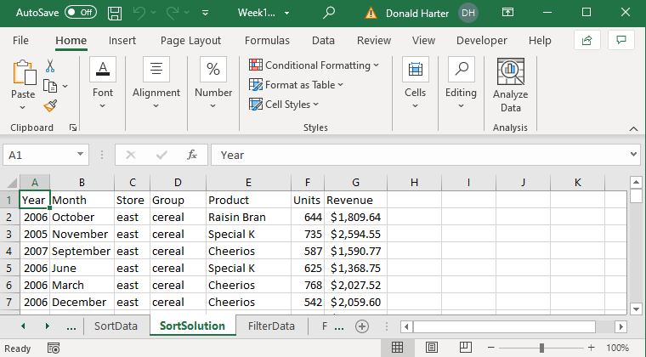

**Filters**

1. Use the FilterData spreadsheet for this exercise.
2. A filter allows you to select specific subset of data out of a long list.
3. First, click on cell A1, then click on the Data tab, then Filter (looks like a funnel).

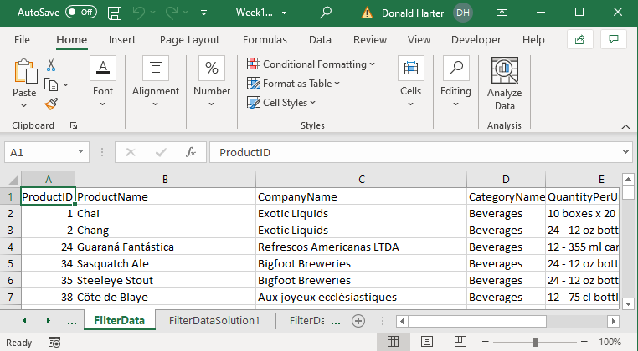

1. Notice that there are drop down arrows for each column. Let’s find all products which Exotic Liquids produces.
2. Click on the drop-down arrow next to company name; uncheck “(Select All),” then check Exotic Liquids and OK. What happens?

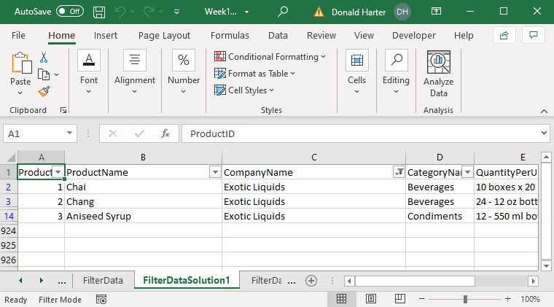

1. Go back and click (Select All) for Company Name.
2. To find which products have a unit price greater than 50, click on the down arrow next to unit price, Number Filters, Greater Than, enter 50 in the field, and click OK.
3. You can turn on multiple filters. Add a filter for Category Name equal to Meat/Poultry to see which Meat/Poultry products cost more than 50.

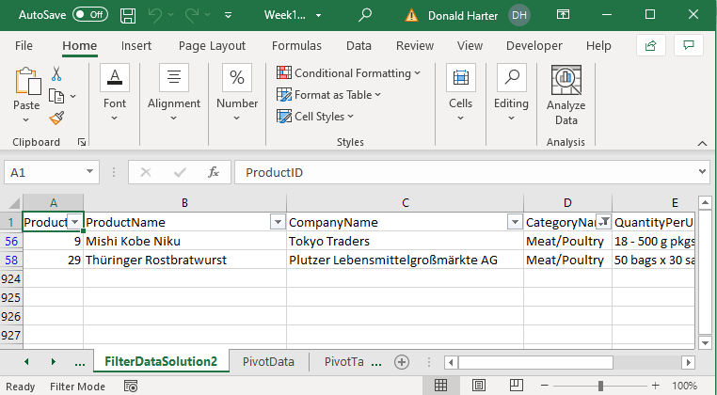

1. To turn off the filter, click on the Filter icon and the drop-down arrows should disappear.

**1.4.4 Excel: Pivot Tables and Charts Demo**

Pivot tables and charts are powerful techniques to quickly summarize and display large amounts of data. For this example, use the PivotData spreadsheet.

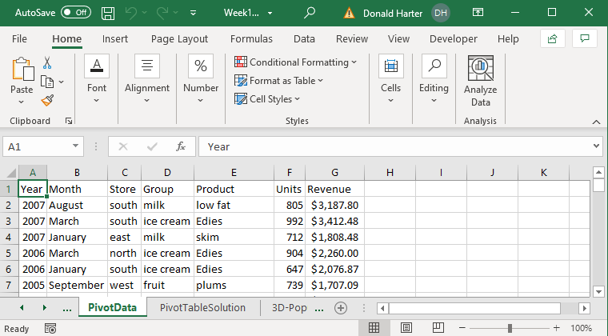

1. The headings must be in the first row of your data.
2. Click anywhere in the data table.
3. Click on the Insert tab.
4. Click on PivotTable; it should automatically highlight the entire table.
5. Make sure New Worksheet is checked, then click OK.

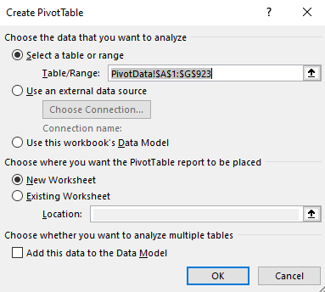

1. In the pivot table dialog box, we want to add row labels, column labels, and identify what goes into the table.
2. For this example, let’s build a table with store revenue by year. First click on store and drag it to the row label. These will become the row labels on the left side of your table.
3. Next, click on year and drag it to the column label. These will become the column labels at the top of your table.
4. Finally, click on revenue and drag it to the values cell. These values will feed the interior of the table. The default function is Sum. If you want to change this function, click on the down arrow in the values box, then select the function (average, min, max, etc.).

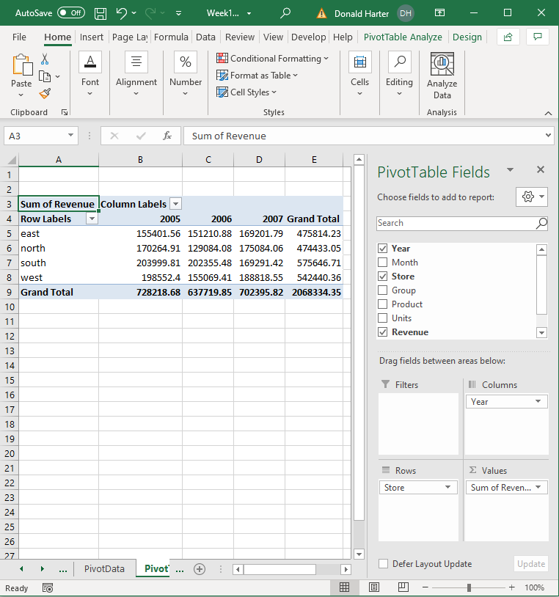

1. Add group to the row labels to see what happens. Drag Group to Rows under Store.

1. Uncheck Group to remove this level of detail.
2. To add a filter to the pivot table, drag Group to Filters.
3. In the upper left corner, click on cell B1 to use the drop-down arrow to select Cereal.

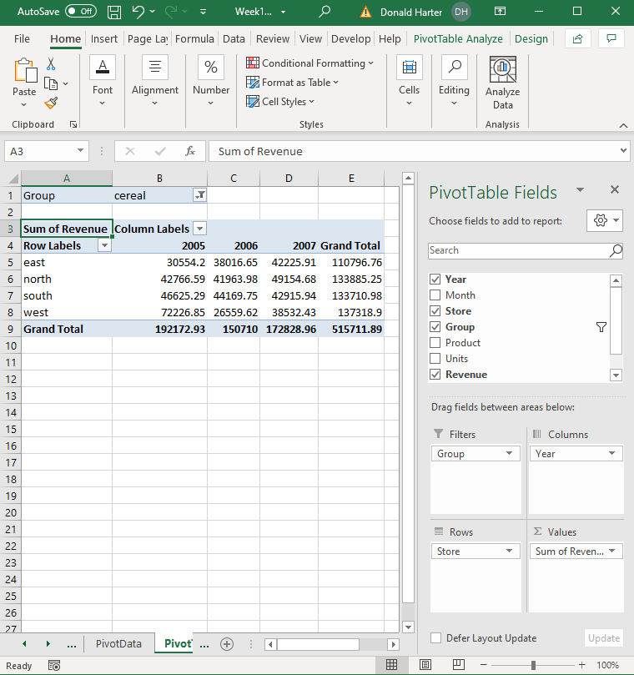

1. To select more than one Group, use the drop-down arrow in cell B1, check the box Select Multiple Items, then choose the Groups that you want to include in the filter.
2. In the Pivot table fields box, uncheck Groups to remove the filter.

**Pivot Chart**

Let’s now create a Pivot Chart. The steps are:

1. Uncheck Group to simplify the data.
2. Click anywhere inside your Pivot Table. An Analyze tab will appear. Click on the Analyze tab, then Pivot Chart.
3. A chart dialog box will appear. Click on your preferred type of chart.

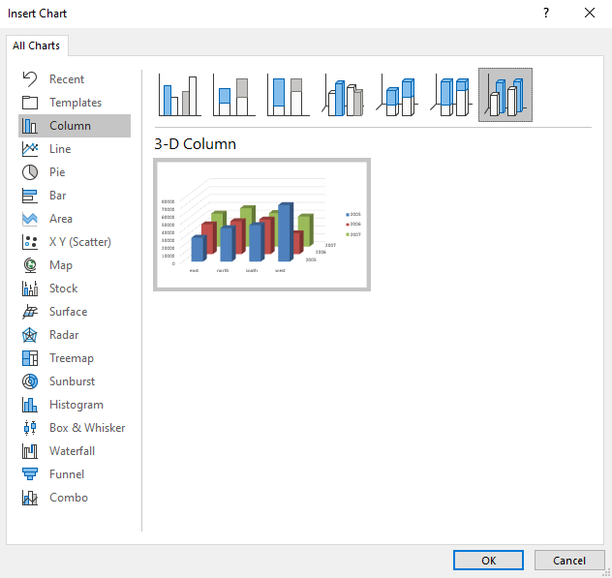

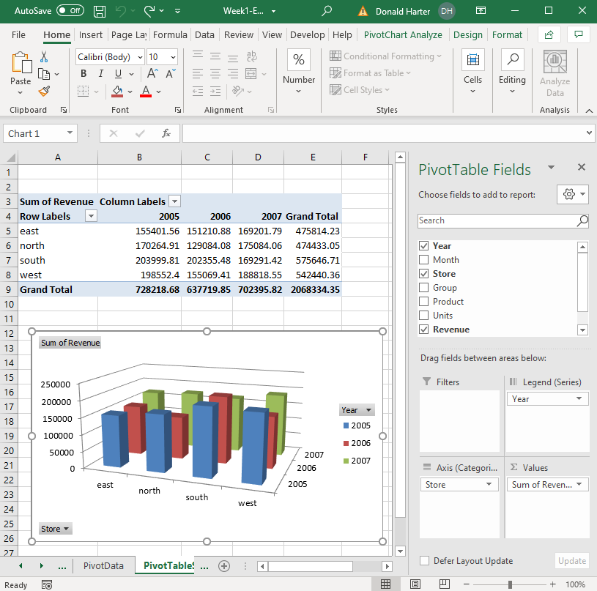

To move the chart to its own page:

1. Right click on the picture.
2. Click on Move Chart.
3. Select New Sheet and name the new sheet.

**1.4.5 Excel: 3D Maps Demo**

Data: Use the 3DMap-Population and 3D-Powerstations worksheets for these exercises.

Objective: Create a geographic map with data superimposed on the map.

For this exercise, use the 3D Maps data on power plants in the United States and the population of each state over time. 3D Maps allows you to plot data on geographic maps and create videos displaying the data.

* + - 1. Click on the 3D Population tab at the bottom of the spreadsheet. This data is official census data of the population of each state in the US from 1900 to 2010.

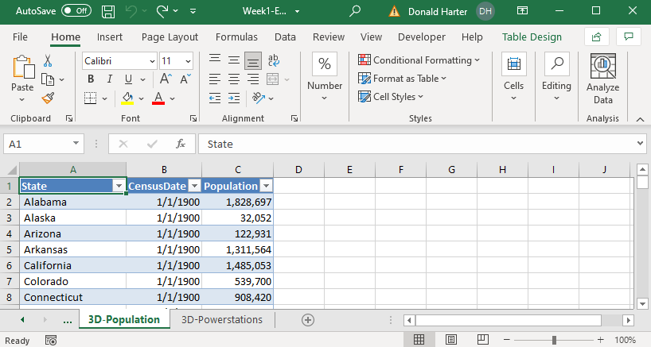

* 1. Click on Insert at the top of Excel, then 3D-Maps, then Open 3D Maps.
  2. Excel will populate the map. The map below is not very interesting.

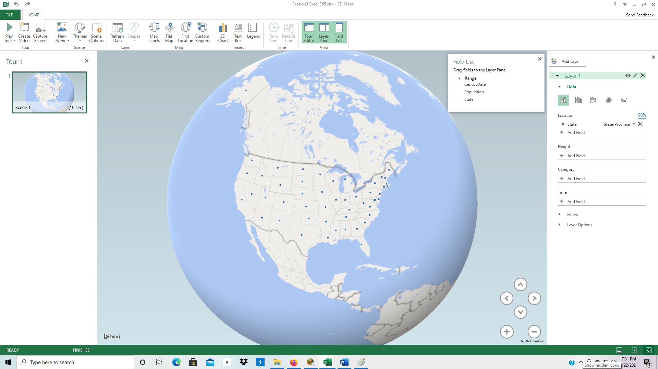

* 1. Under Layer 1, Data, click on Change Visualization to Region.

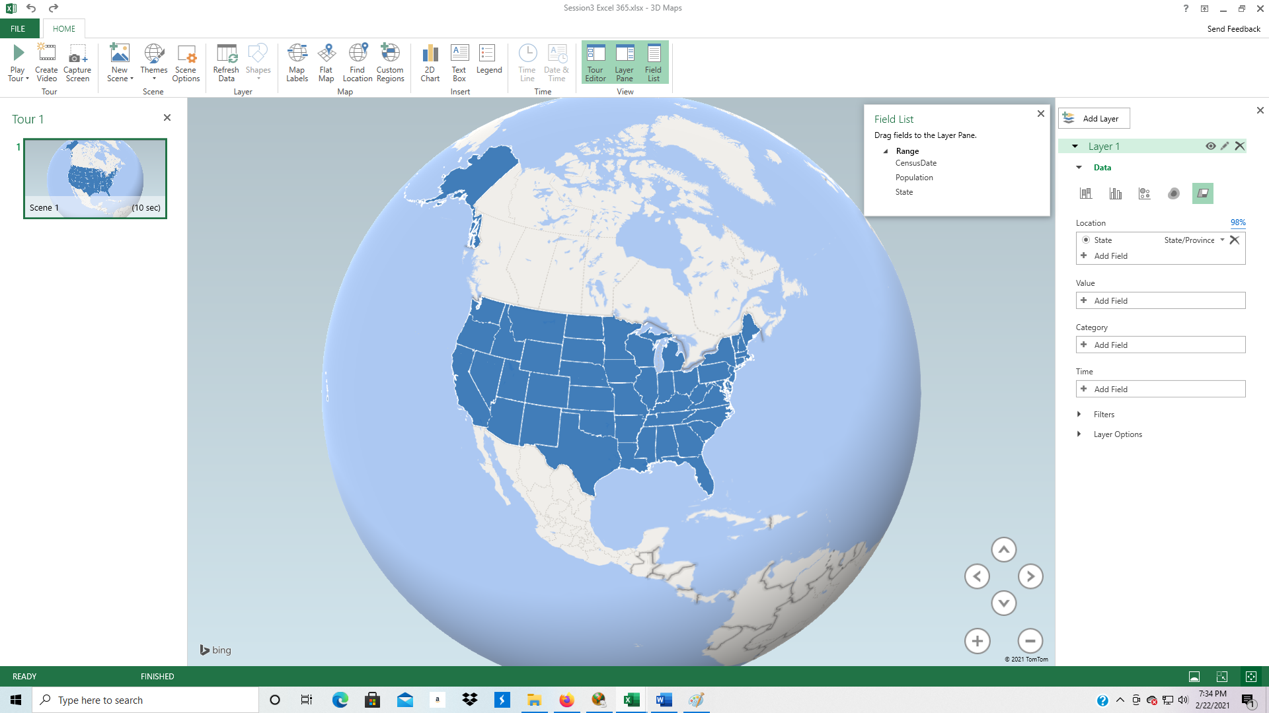

* 1. Still not very interesting; all the states are the same color.
  2. In the Field list, drag the Population to Value in Layer 1.

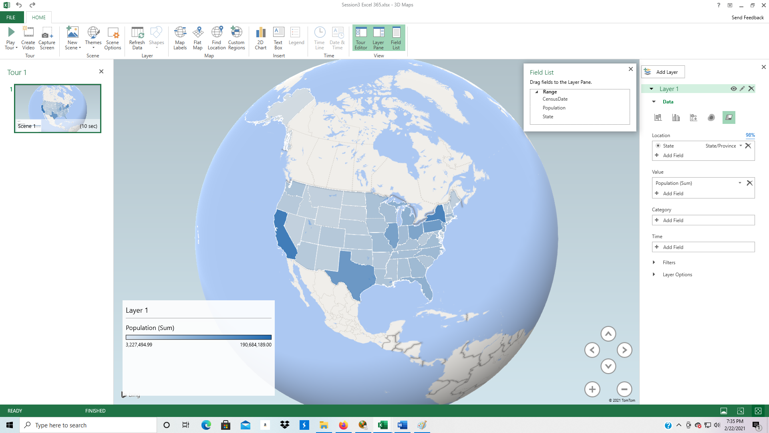

* 1. In the Field list, drag CensusDate to Time in Layer 1.
  2. At the bottom of the screen is now an arrow to play the video from 1900 to 2010.
  3. Click the arrow. When it is playing, you can stop the video by clicking on the timeline or move to any specific time.

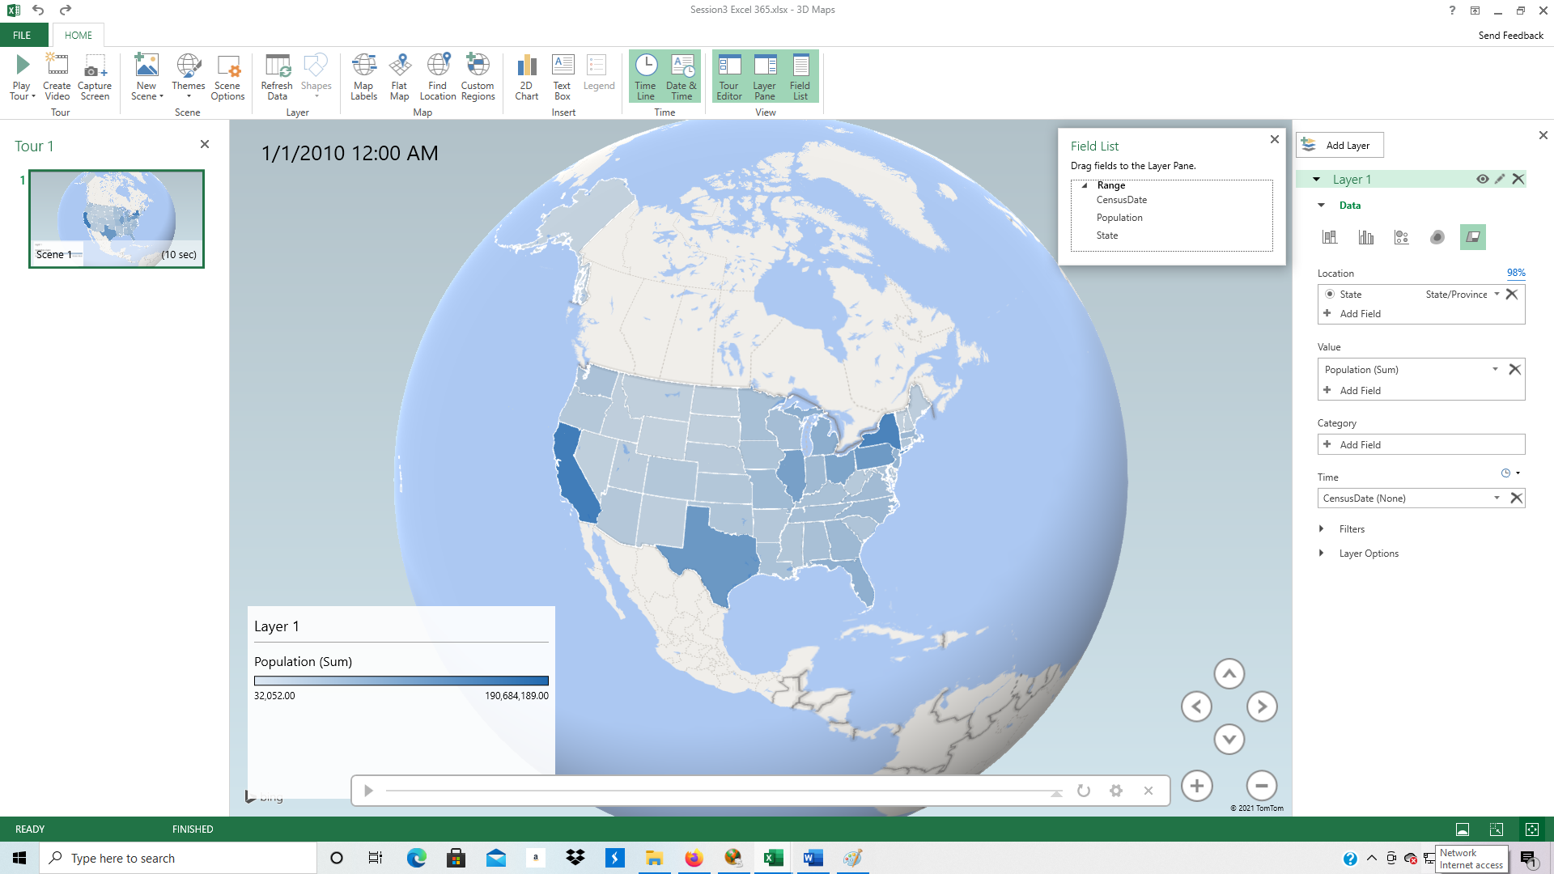

* 1. To add a second Layer, click back on the data in the spreadsheet.
  2. Click on the 3D-PowerStations tab.

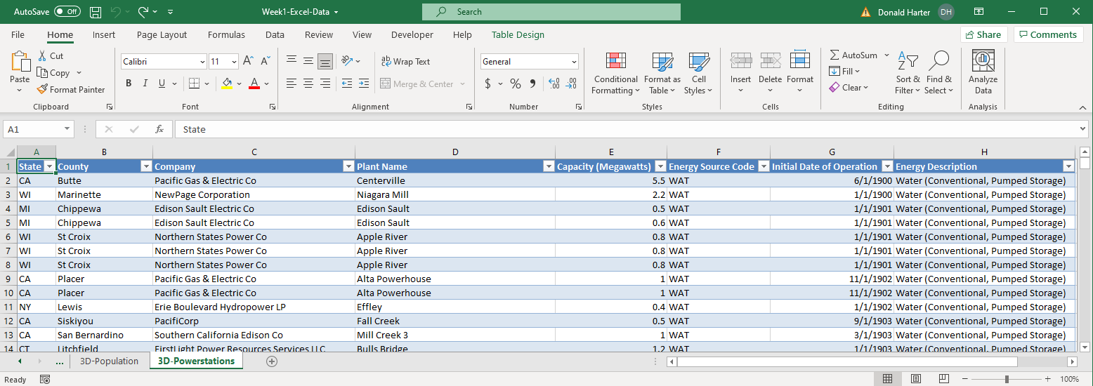

* 1. Click on the Insert tab, 3D Map, Add Selected Data to 3D Maps.

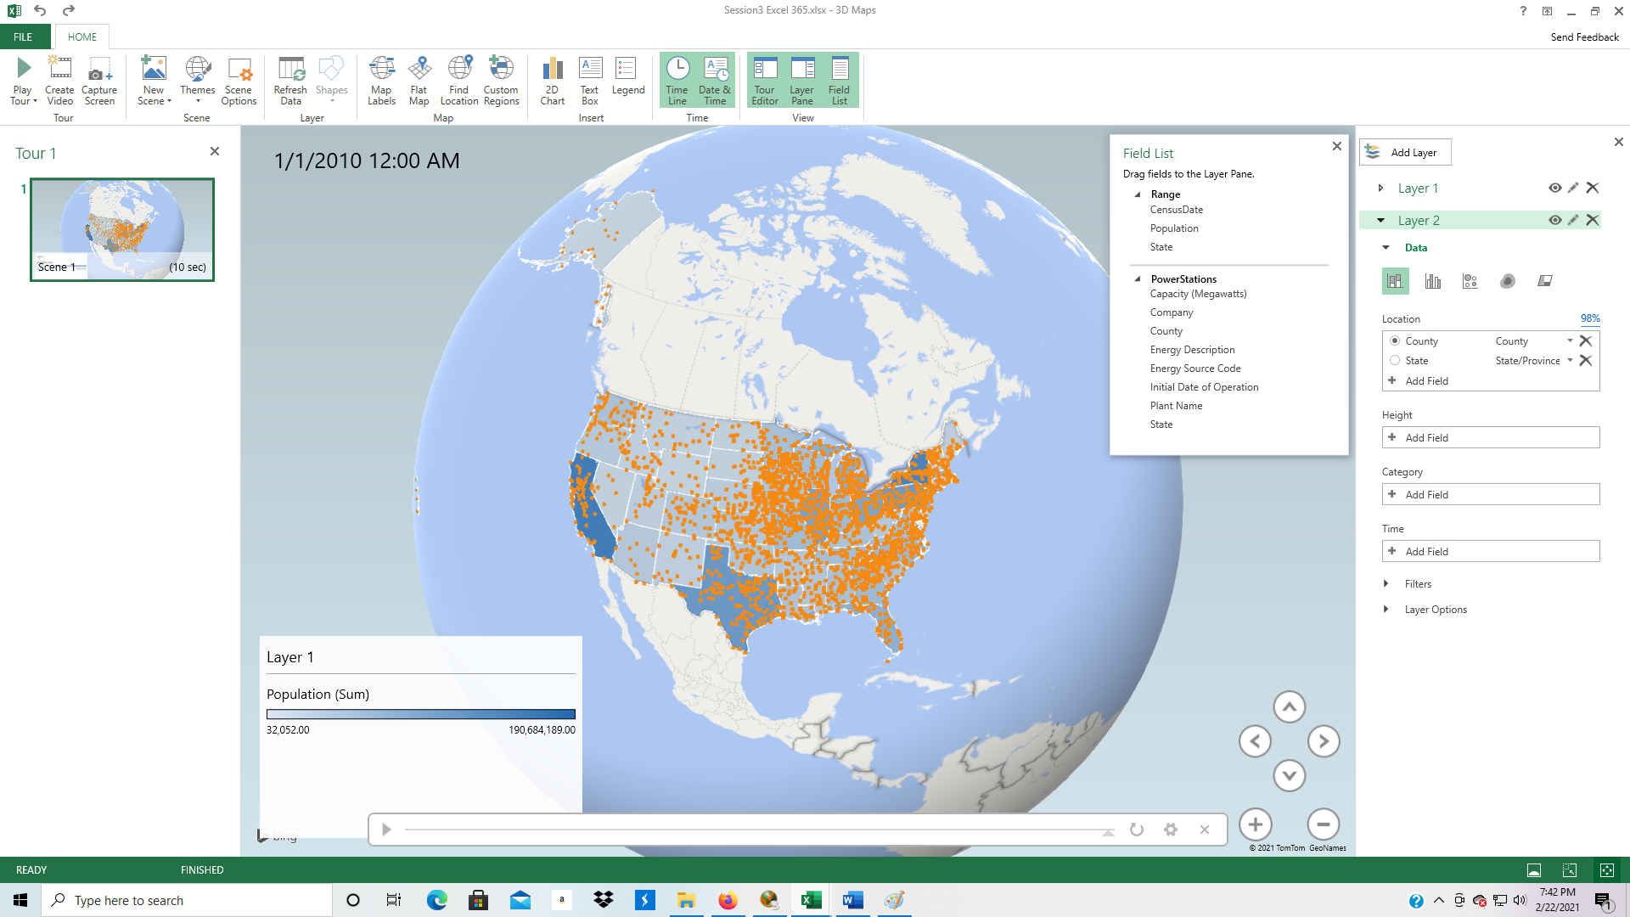

* 1. Next we are going to add a measurement scale to each data point. From the Field List, PowerStations, drag Capacity (Megawatts) to Height (Add Field).

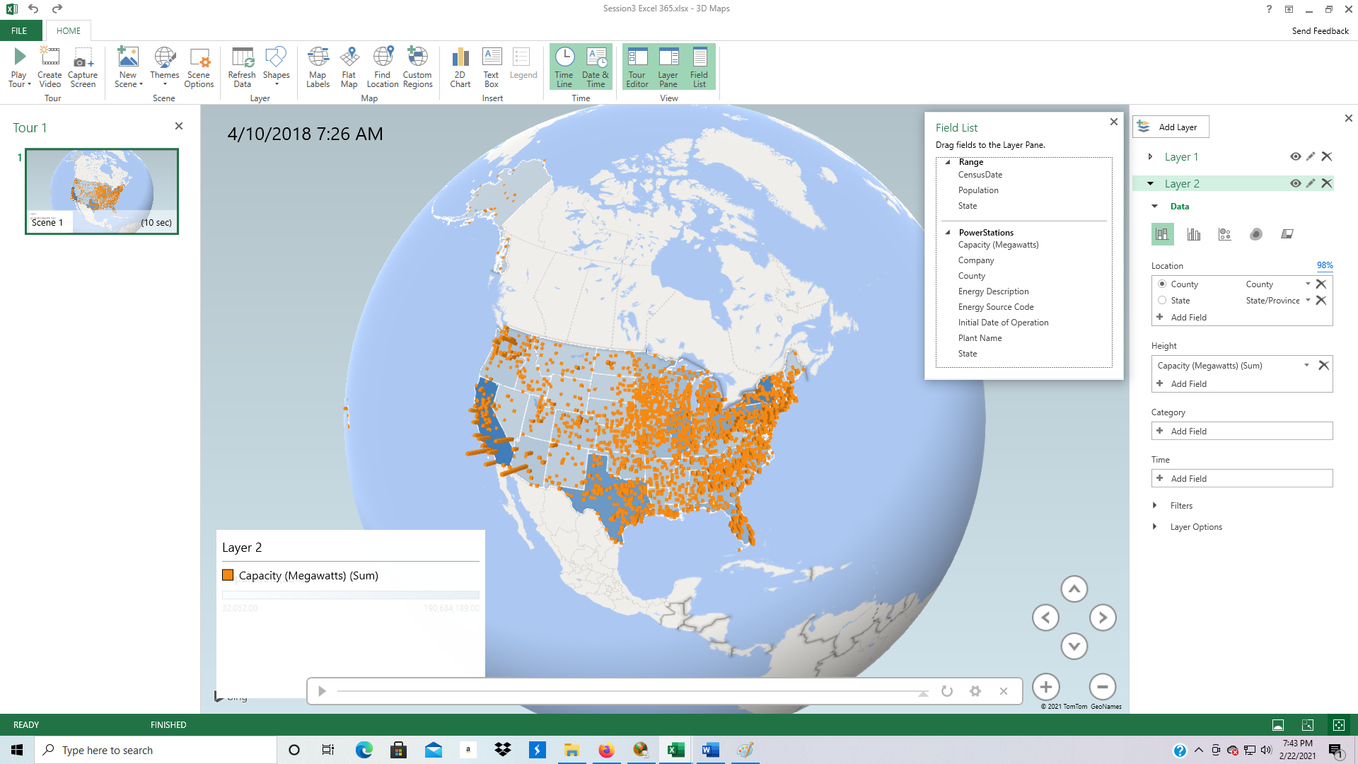

* 1. Next, we can color code categories of Power Stations by dragging Energy Description from Field List, PowerStations to Category (Add Field) on the right side of the screen.

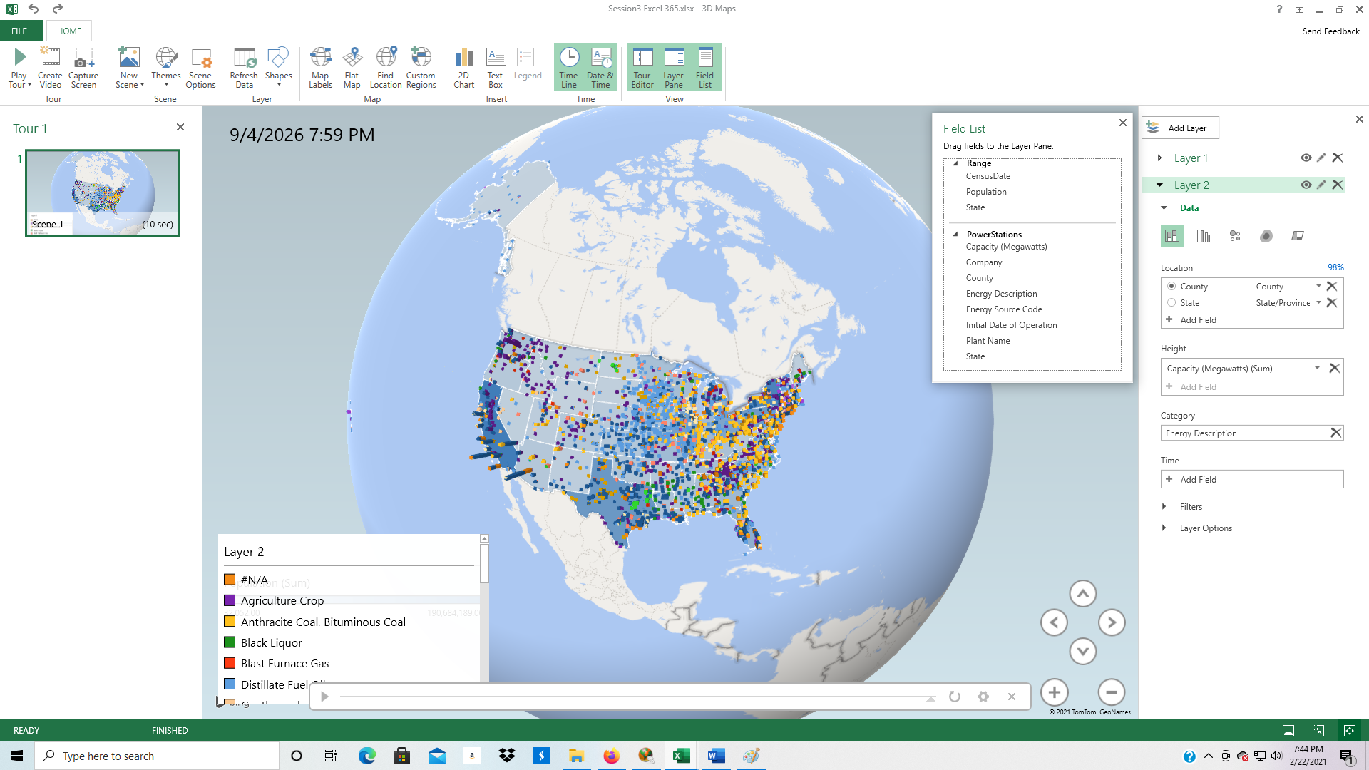

* 1. To add a timeline to the data, drag Initial Date of Operation from Field List, PowerStations to Time (Add Field) on the right side of the screen.
  2. The video play bar appears at the bottom of the screen. You can click on the arrow at the left of the video play bar to play the animation over time.
  3. The next feature allows us to add a filter to the display. Click on the arrow next to Filters on the right. Click on the Add Filter under Filters. Click on Energy Description to turn on that filter. You can now select Geothermal, Solar, and Wind for renewable energy.

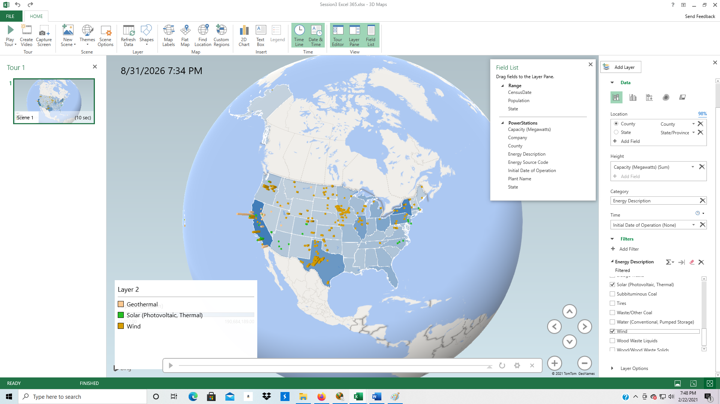

**Creating a Video**

1. To create a video, we first need to create new scenes. Click on New Scene, then rotate the globe to show Hawaii. You can create as many scenes as you want.

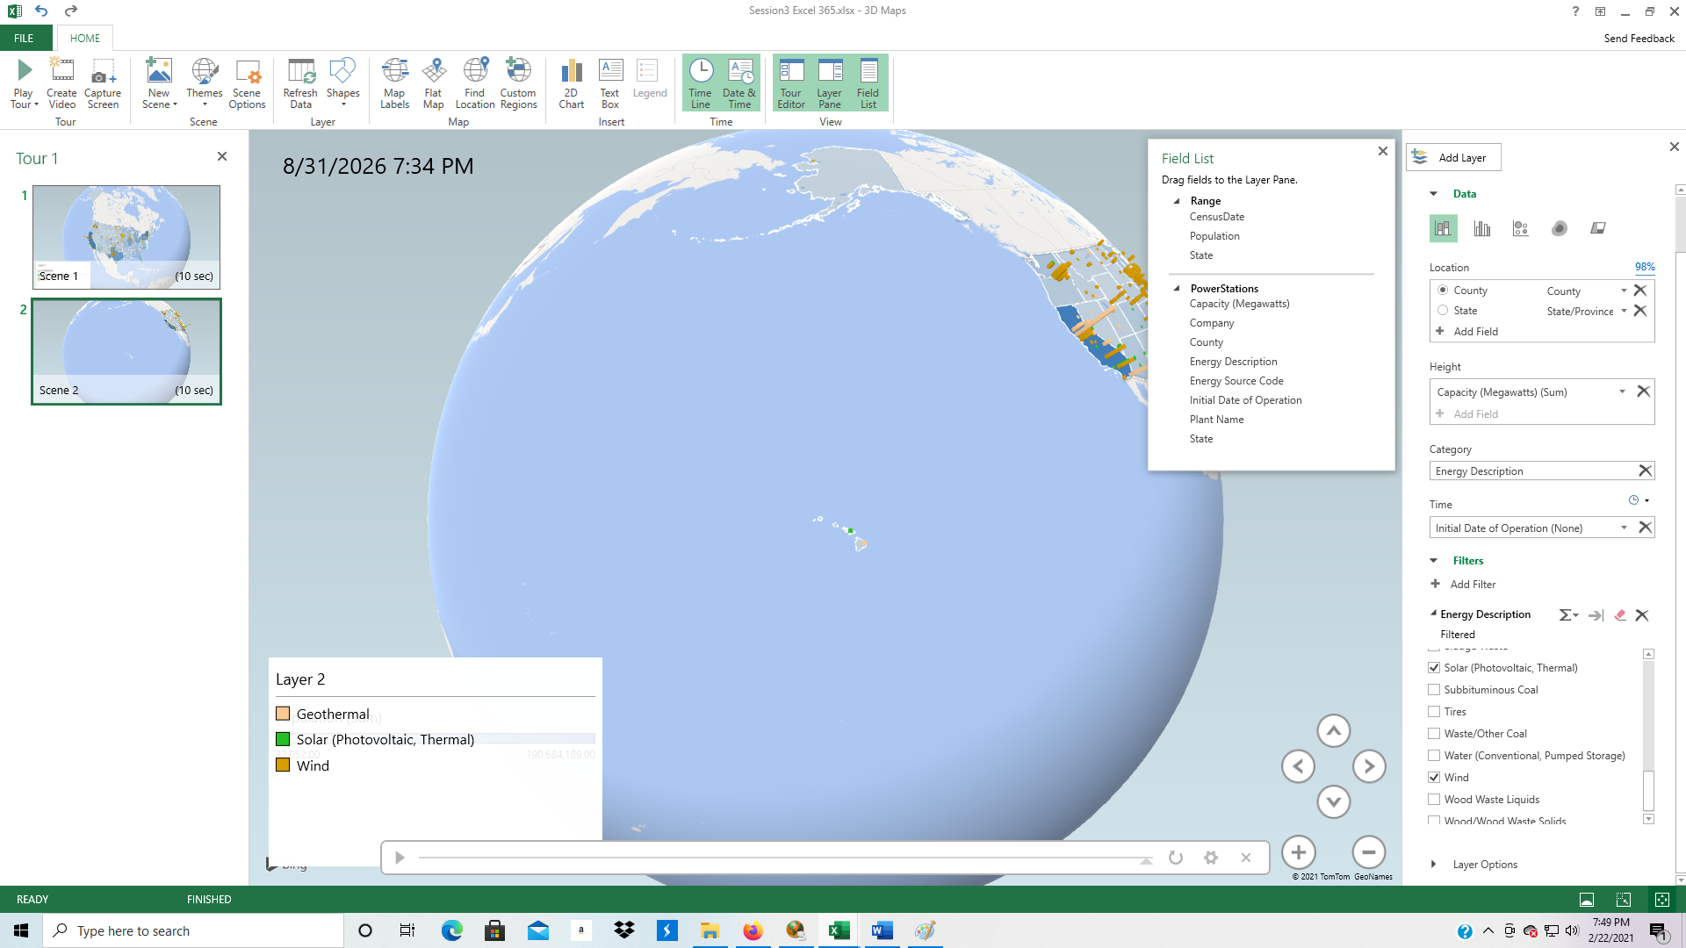

1. Click New Scene, then rotate the globe to show Alaska.

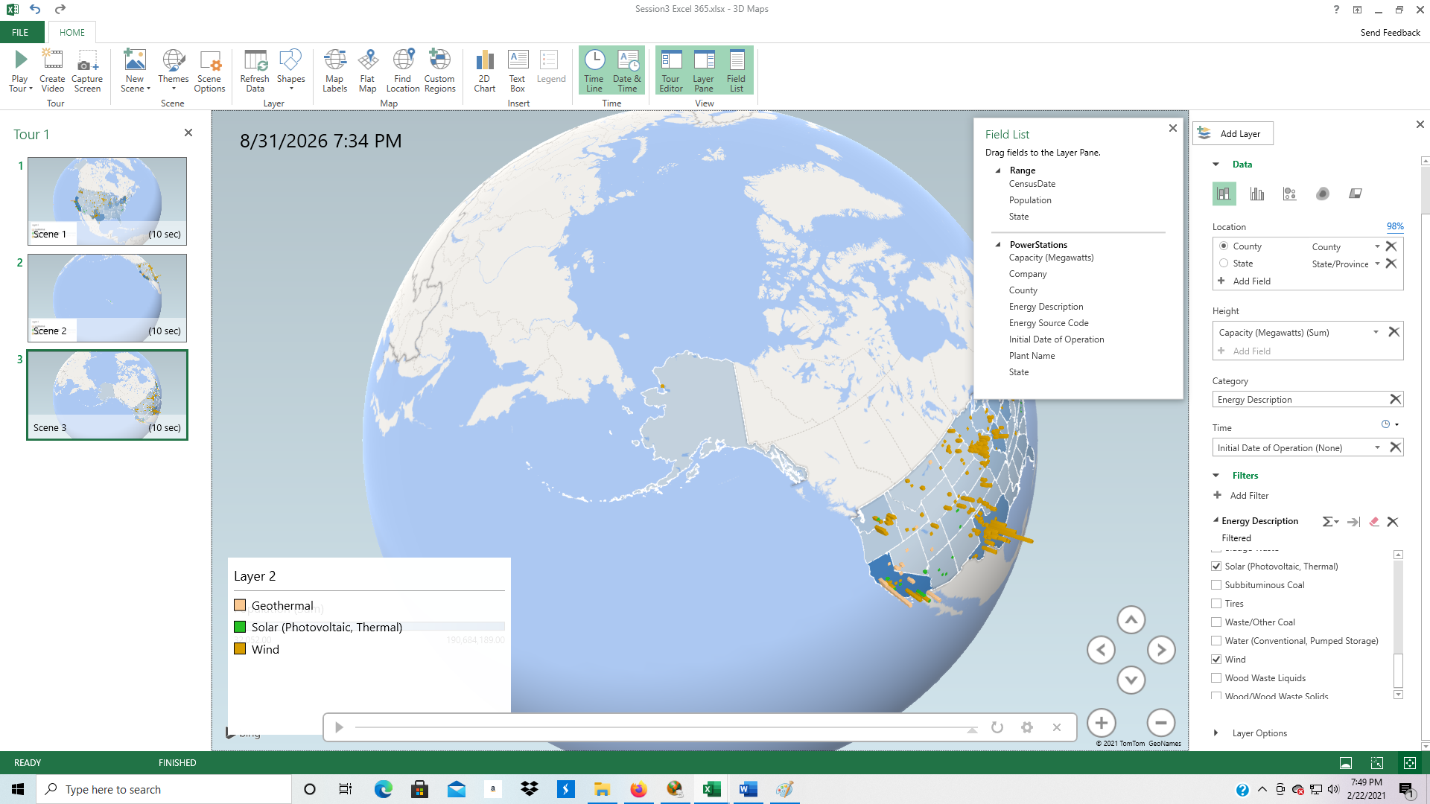

1. To play the video, click Play Tour.
2. If you want to save the video to your computer, click on Create Video.

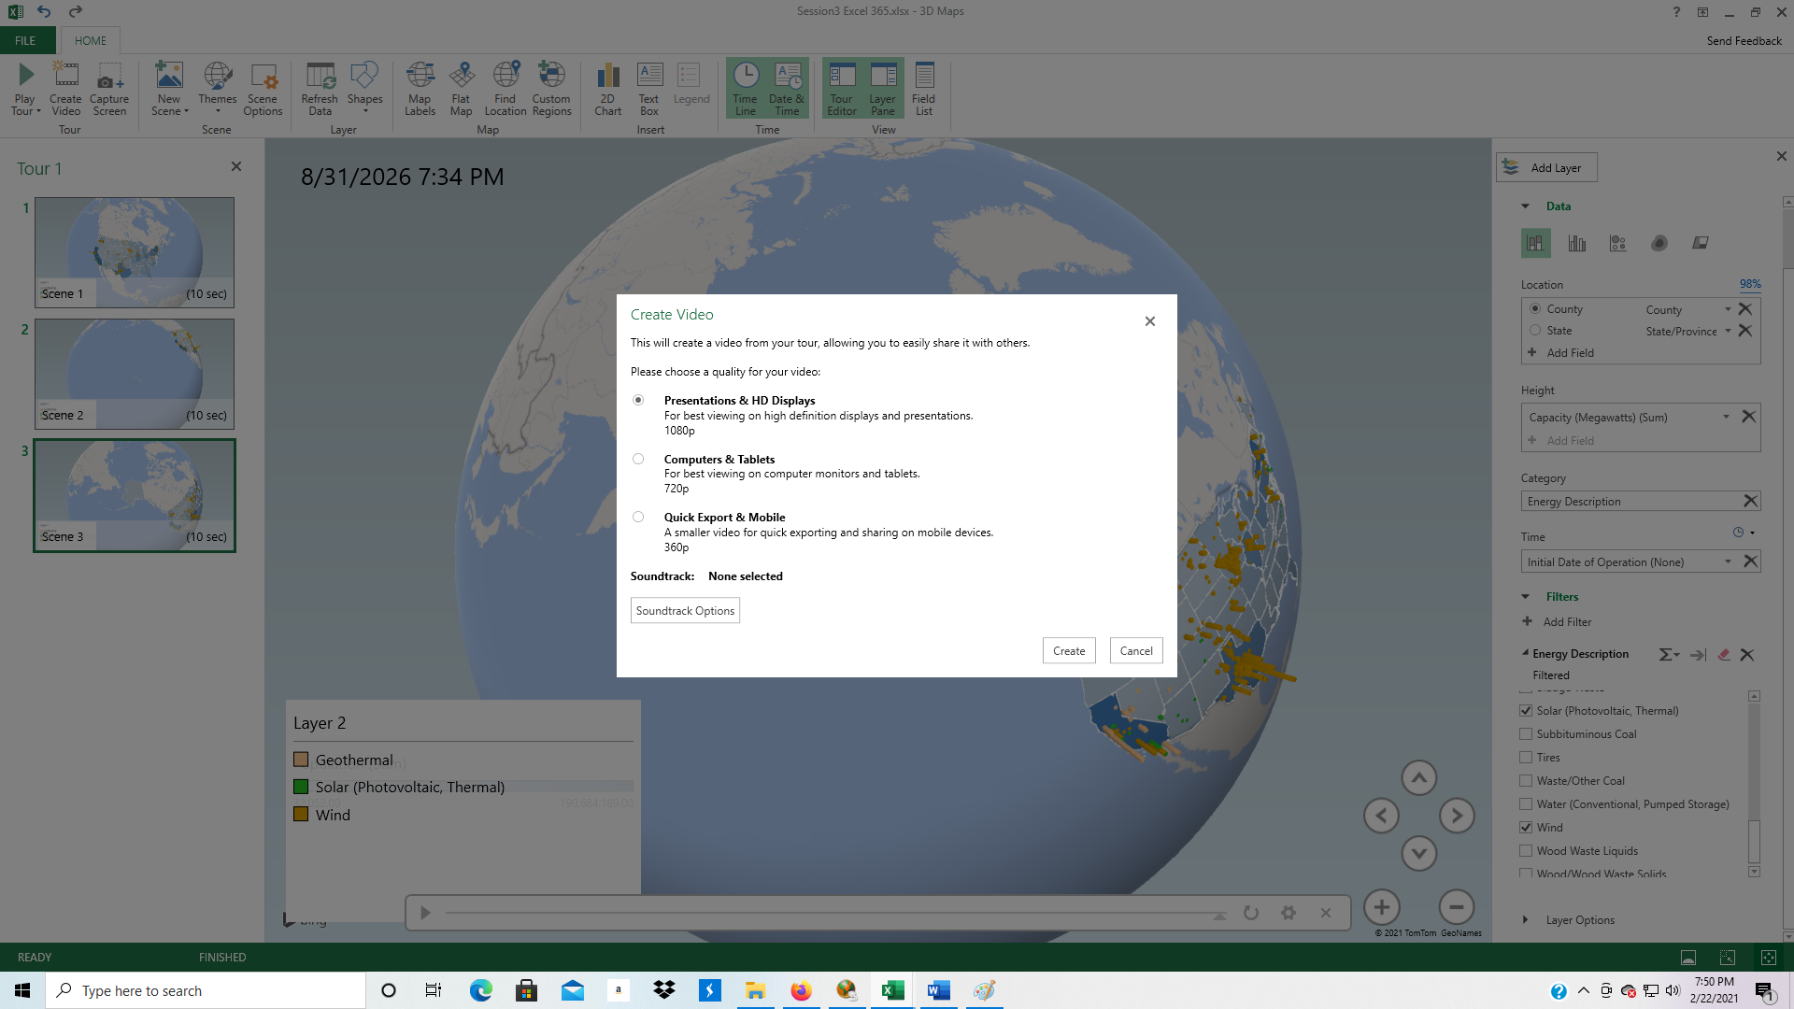

1. Select Presentations & HD Displays if you have a high-definition screen. Otherwise select a low-resolution option.
2. Click Create, and save the video to your computer.

**Earth from a Different Perspective**

Most maps are displayed flat rather than round like a globe. If you believe that the earth is flat, click on the Flat Map button at the top of the screen.

